Introduction
Customer churn occurs when customers or subscribers stop doing business with a company or service, also known as customer attrition. It is also referred as loss of clients or customers. One industry in which churn rates are particularly useful is the telecommunications industry, because most customers have multiple options from which to choose within a geographic location.

Problem Statement
With the increasing competition in the streaming service market, accurately identifying which customers are likely to cancel their subscriptions ("churn") is crucial for businesses to proactively retain customers and optimize pricing strategies. However, traditional methods of churn prediction often rely on limited customer data, leading to inaccurate predictions.

Why Customer Churn Analysis Important for Telecom Industry
There are multiple areas this analysis is so important for telecom industry for future growth and the pros and cons to consider for customers and streaming services and subscription verities of customer required based on demographics and location etc.

Here are the 3 important aspects

Revenue Impact: Churn directly affects a streaming service's revenue, as lost subscribers represent lost income.

Targeted Marketing: By identifying at-risk customers, companies can implement targeted retention campaigns, offering personalized incentives to encourage continued subscriptions.

Improved Content Strategy: Analyzing churn patterns can provide valuable insights into what content types or viewing habits are most likely to lead to customer loss, allowing for better content curation and development.

Why Telecom Industry a Data Science Problem
Telecom Industry Churn Analysis is considered a classic data science problem, specifically falling under the category of "classification" where the goal is to predict whether a customer is likely to churn (leave the service) based on their usage patterns and other relevant data, allowing companies to proactively take steps to retain them; this typically involves using machine learning algorithms to analyze customer data and identify patterns that indicate churn risk.

Data science plays a crucial role in churn analysis in telecom. Data scientists use a range of techniques, including machine learning and predictive analytics, to analyze customer data and develop models that predict which customers are at risk of churning.

Here are few data points detailed out –

Large Data Sets: Streaming services collect vast amounts of user data including viewing history, time spent watching, device usage, genre preferences, and demographic information, which can be analyzed using machine learning algorithms to identify patterns associated with churn.

Feature Engineering: Extracting meaningful features from raw data, such as calculating "days since last viewing" or "number of unique titles watched" is critical for building accurate predictive models.

Model Selection: Choosing the appropriate machine learning algorithms (e.g., Logistic Regression, Random Forest, Gradient Boosting) based on the data characteristics and desired prediction accuracy is essential.

Evaluation Metrics: Metrics like precision, recall, and AUC-ROC are used to assess the performance of churn prediction models, allowing for comparison and optimization.

Research Questions

Does the payment method contribute to why customers churn?

What is the Distribution of Tenure over the period, the maximum and minimum.

How does the length of a customer’s contract affect their likelihood to churn?

On an average monthly charge did customers pay to enjoy a particular Internet Service and how did it affect customer Churn.

What are the average monthly charges of Senior Citizens and Non-Senior under a particular payment method and how does it affect customer Churn.

Methodology

Overview

Data Collection: Gather telecommunication data from the specified sources.

Data Preprocessing: Clean and prepare the data, handling missing values and normalizing where needed.

Exploratory Data Analysis (EDA): Using statistical summaries and visuals to examine the data to understand trends, relationships, and essential characteristics.

Feature Selection: Identify the most impactful factors related to customer churn analysis data.

Model Development: Use statistical methods to create models that predict churn risk.

Model Evaluation: Test the models to see how well they predict, using accuracy and other relevant metrics.

Interpretation and Recommendations: Conclude our analysis and suggest practical actions based on the findings.

Data Handling and Analysis Plan

Data Preprocessing: Import and clean data to ensure accuracy. Handle missing values through methods like imputation.

Exploratory Data Analysis (EDA): Use summary statistics and visual tools (like histograms and scatter plots) to get a clear view of the data’s characteristics.

Feature Selection and Model Development: Analyze correlations to pick key risk factors and build and compare different predictive models.

Model Evaluation and Reporting: Evaluate each model’s performance.

Use the results to make straightforward recommendations for customer churn in telecom industry.

Data

Data Preprocessing
Each row represents a customer, each column contains that customer’s attributes and here are the following libraries used for EDA and data cleaning and data processing and different plot and histograms.

library(dplyr)
library(plyr)
library(tidyr)
library(stringr)
library(readxl)
library(corrplot)
library(ggplot2)
library(tidyverse)
library(gridExtra)
library(ggthemes)
library(caret)
library(tibble)
library(MASS)
library(randomForest)

library(party)churn <- read.csv('Telco-Customer-Churn.csv')
str(churn)

The dataset contains information about various customer attributes and their subscription services, which can be used to predict customer churn.

Objective: Predict customer churn based on customer attributes and their subscription services.

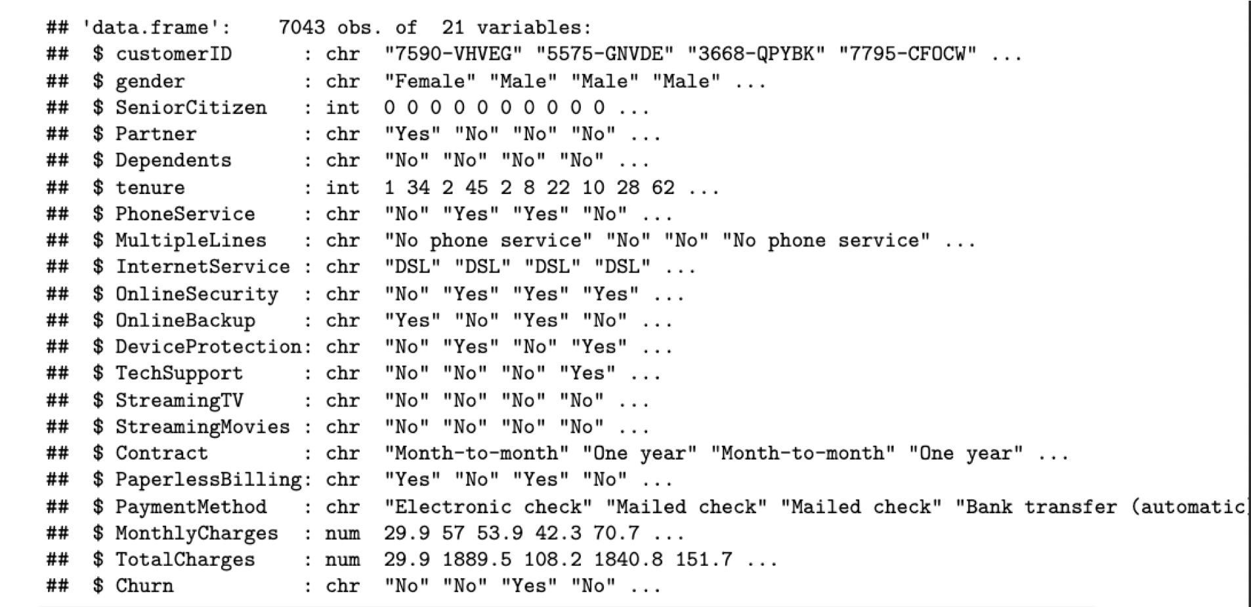

Following are the categories for different attribute Information

Identifier
- customerID - ID number of the customer

Target Variable
- Churn - Churn status, whether the customer churned or not
- Demographic information
- gender - Whether the customer is a male or a female
- SeniorCitizen - Whether the customer is a senior citizen or not
- Partner - Whether the customer has a partner or not
- Dependents - Whether the customer has dependents or not

Customer account information
- tenure - Number of months the customer has used the service
- Contract - The contract term of the customer
- PaperlessBilling - Whether the customer has paperless billing or not
- PaymentMethod - The customer’s payment method
- MonthlyCharges - The amount charged to the customer monthly
- TotalCharges - The total amount charged to the customer

Services that each customer has signed up for
- PhoneService - Whether the customer has a phone service or not
- MultipleLines - Whether the customer has multiple lines or not
- InternetService - Customer’s internet service provider
- OnlineSecurity - Whether the customer has online security or not
- OnlineBackup - Whether the customer has online backup or not
- DeviceProtection - Whether the customer has device protection or not
- TechSupport - Whether the customer has tech support or not
- StreamingTV - Whether the customer has streaming TV or not
- StreamingMovies - Whether the customer has streaming movies or not

The raw data contains 7043 rows (customers) and 21 columns (features). The “Churn” column is our target.

using sapply to check the number if missing values in each column. I found that there are 11 missing values in “TotalCharges” columns. So, let’s remove all rows with missing values.

sapply(churn, function(x) sum(is.na(x)))

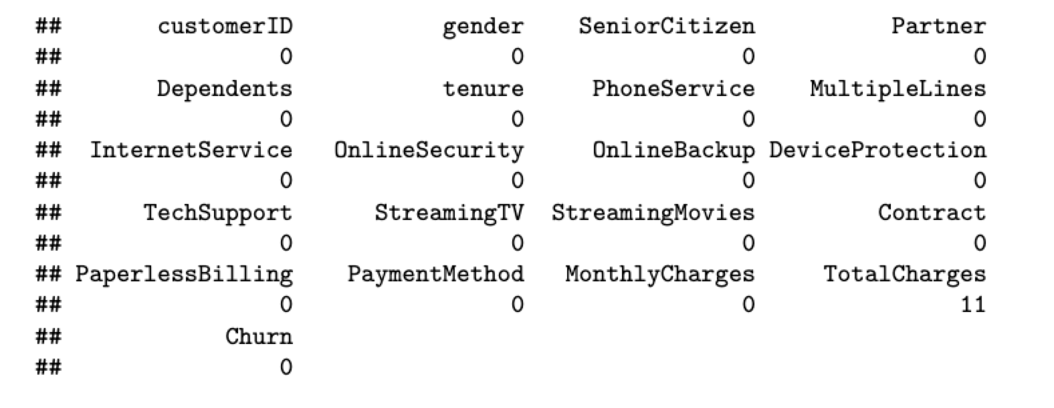

Let’s check the data structure of the dataset

summary(dat)
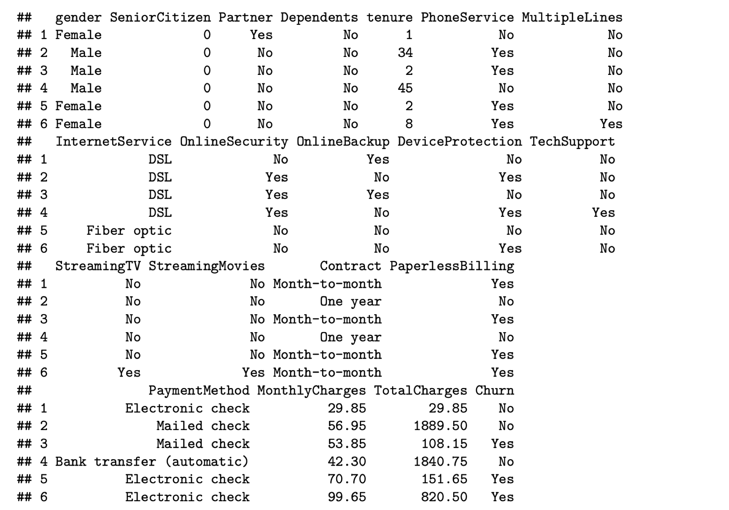

The "SeniorCitizen" variable in the dataset is currently coded as a binary variable with values of "0" or "1". This coding scheme is not intuitive and can be difficult to interpret.
To make our analysis easier and more understandable, I can recode this variable using a more intuitive labeling scheme, such as "yes" and "no".

The "MultipleLines" variable is related to the "PhoneService" variable. If "PhoneService" is set to "No", then "MultipleLines" is also automatically set to "No".

To simplify our graphics and modeling, can change the "No phone service" response in the "MultipleLines" variable to "No".
Same goes with "No internet service"

datrecode <- churn %>%
mutate(SeniorCitizen = if_else(SeniorCitizen == 0, "No", "Yes")) %>%
mutate(MultipleLines = if_else(MultipleLines == "No phone service", "No", MultipleLines)) %>%
mutate(across(starts_with("Online") | starts_with("Device") | starts_with("Tech") | starts_with("Streaming"),~if_else(.== "No internet service","No", .)))
head(datrecode)
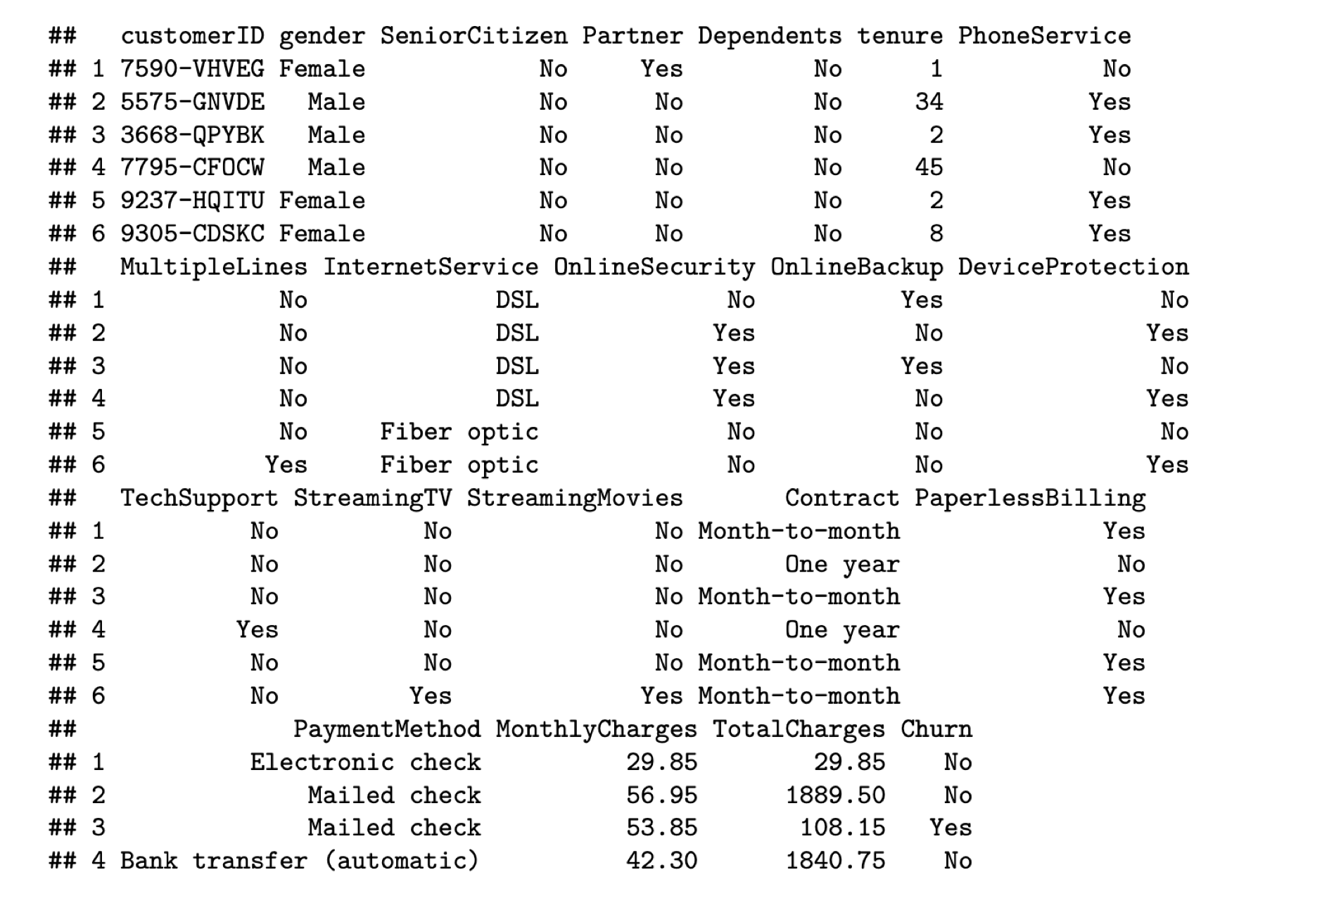

Plots and Table Needs

Plots

Histograms and Density Plots: To show the distribution of continuous variables such as Internet Services, Payment Method etc. These plots can help identify skewness, outliers, and typical ranges within the data.

Box Plots: Ideal for comparing distributions across different categories, such as comparing monthly or total charges or churn by gender or age group. Box plots are useful for visually summarizing data and highlighting differences between groups.

Scatter Plots: To explore potential relationships between continuous variables, like monthly charges or churn for Senior Citizens and other factors.

Bar Charts: To display categorical data, such as the prevalence of by different demographic regions.

Correlation Heatmaps: A heatmap can be used to visualize the correlation matrix of the variables. This is especially helpful in identifying which variables are most closely related.

ROC Curves: Useful for evaluating the performance of predictive models. ROC curves and the area under the ROC curve (AUC) provide a powerful visual tool for assessing the true positive rate against the false positive rate.

Tables

Descriptive Statistics Table: A comprehensive table summarizing the key statistics (mean, median, standard deviation, min, max) for each variable in your dataset. This table provides a quick reference for understanding central tendencies and dispersions.

Risk Factor Analysis Table: Tables that detail the outcomes of analyses concerning specific risk factors, showing odds ratios, confidence intervals, and significance levels.

Comparison Tables: These are used to compare metrics across different models or different groups within data. These include sensitivity, specificity, precision, and recall of different predictive models.

Exploratory data analysis and feature selection

First look at the variables, that can use for data wrangling purpose.

- will change “No internet service” to “No” for six columns, they are: “OnlineSecurity”, “OnlineBackup”, “DeviceProtection”, “TechSupport”, “streamingTV”, “streamingMovies”.

cols_recode1 <- c(10:15)
for(i in 1:ncol(churn[,cols_recode1]))
{
churn[,cols_recode1][,i] <- as.factor(mapvalues
(churn[,cols_recode1][,i],from =c("No internet service"),to=c("No")))
}
- will change “No phone service” to “No” for column “MultipleLines”
churn$MultipleLines <- as.factor(mapvalues(churn$MultipleLines,
from=c("No phone service"),to=c("No")))
- Since the minimum tenure is 1 month and maximum tenure is 72 months, grouping them into five tenure groups: “0–12 Month”, “12–24 Month”, “24–48 Months”, “48–60 Month”, “> 60 Month”

min(churn$tenure); max(churn$tenure)

Let’s look at numerical Features
# Histogram of Tenure:
p1 <- ggplot(datrecode, aes(x = tenure)) +
geom_histogram(binwidth = 5, color = "white", fill = "#FFA07A") +
labs(title = "Distribution of Tenure",
x = "Tenure (Months)", y = "Frequency") +
scale_x_continuous(limits = c(0, 80), breaks = seq(0, 80, 5)) +
theme_minimal()
# Histogram of TotalCharges
p2 <- ggplot(datrecode, aes(x = TotalCharges)) +
geom_histogram(binwidth = 200, fill = "#69b3a2", color = "black") +
scale_x_continuous(breaks = seq(0, 9000, by = 1000)) +
labs(x = "Total Charges", y = "Frequency", title = "Histogram of Total Charges")
# Histogram of MonthlyCharges
p3 <- ggplot(data = datrecode, aes(x = MonthlyCharges)) +
geom_histogram(binwidth = 10, color = "white", fill = "#FFA07A") +
labs(title = "Distribution of Monthly Charges",
x = "Monthly Charges ($)", y = "Frequency") +
scale_x_continuous(limits = c(0, 130), breaks = seq(0, 150, 20)) +
theme_minimal()
grid.arrange(p1, p2, p3, ncol = 2)

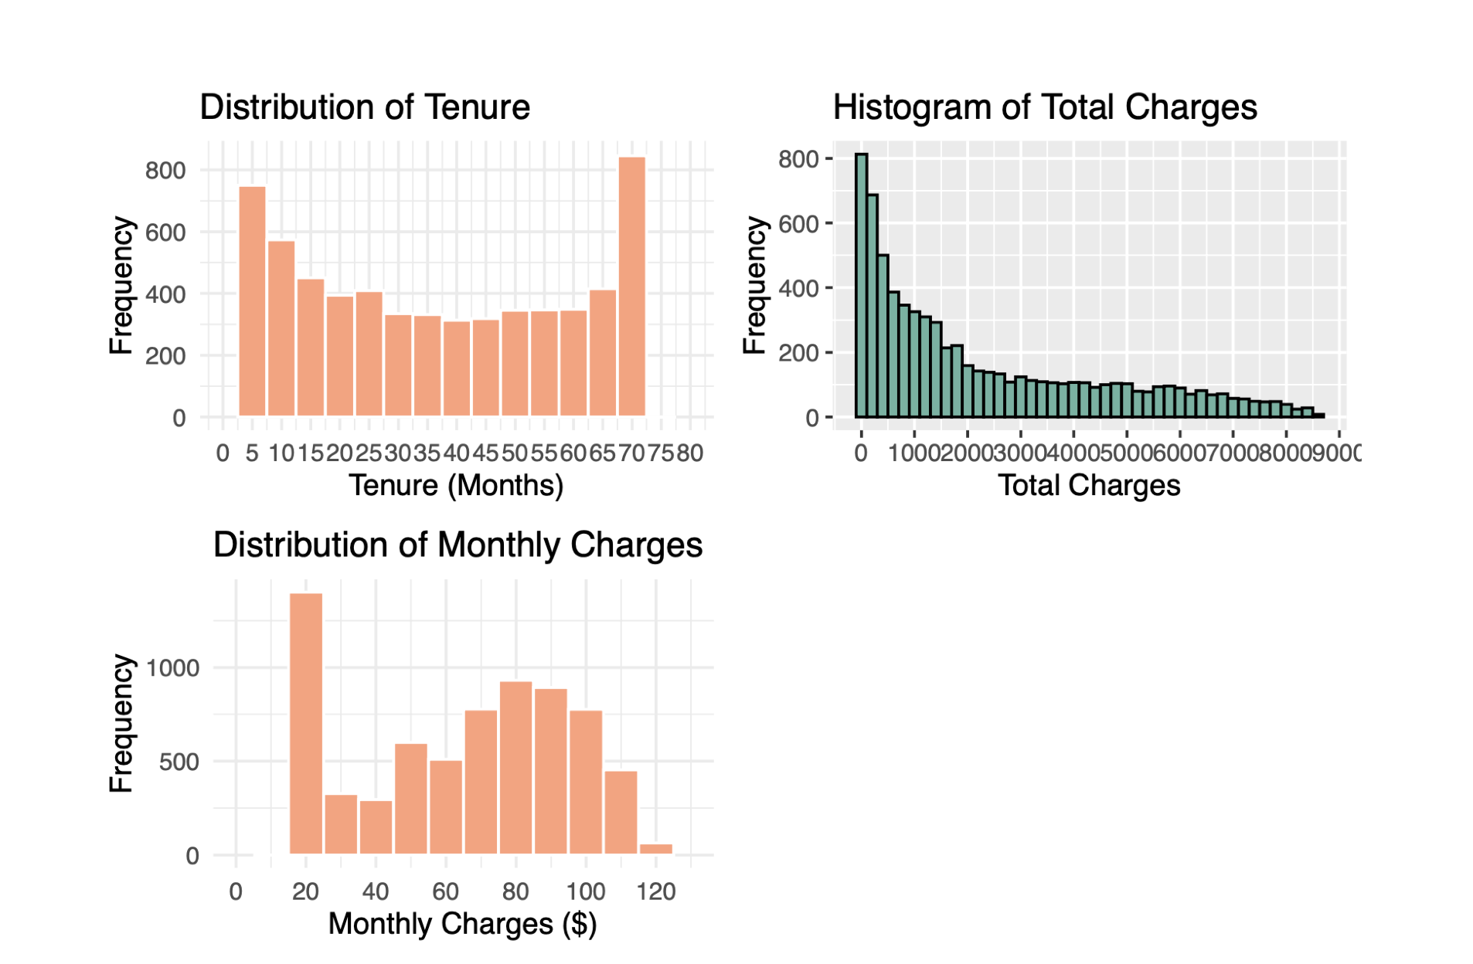

- Maximum frequency (number of customers) is observed in the 0-5- and 65-70-months tenure ranges, whereas the average frequency for intermediate ranges lies between 250 and 400 customers per range.
- The “TotalCharges” graph depicts the distribution of the charged amount to customers, there is a down trend of decreasing frequency and increasing total charges.
- The histogram of “Monthly Charges” shows that most customers have monthly charges between 20-40 dollars and a normal distribution around 80 dollars.

Let’s look at Categorical Features
# Bar graph of Contract
p9 <- ggplot(datrecode, aes(x = Contract, fill = Contract)) +
geom_bar() +geom_text(aes(y = ..count.. -400, label = paste0(round(prop.table(..count..),1)*100, "%")), stat = "count")+labs(title = "Distribution of Contract Type",
x = "Contract Type", y = "Count") +
scale_fill_brewer(palette = "Set2") +
theme(axis.text.x = element_text(angle = 45, hjust = 1))
# Bar graph of gender
colors <- c("#0072B2", "#E69F00")
p10 <- ggplot(data = datrecode, aes(x = gender))+
geom_bar(aes(fill = gender))+
geom_text(aes(y = ..count.. -500, label = paste0(round(prop.table(..count..),4)* 100, '%')),
stat = "count", position = position_stack(vjust = 0.5))+ xlab("Gender") + ylab("Count") + ggtitle("Customer Gender Distribution")+
theme()
# Arrange plots in a grid
grid.arrange(p9, p10)

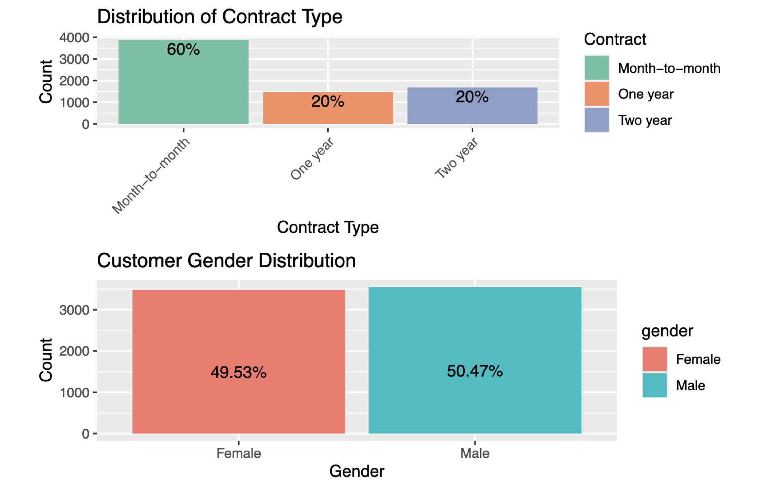

- The most common contract type is Month-to-Month, followed by Two Year and One Year contracts.
- The bar graph indicates an almost equal distribution between genders.

# Bar graph of InternetService
p11 <- ggplot(datrecode, aes(x = InternetService, fill = InternetService)) +
geom_bar() +
labs(title = "Distribution of Internet Service",
x = "Internet Service",
y = "Count") +
scale_fill_brewer(palette = "Set2") +
theme(axis.text.x = element_text(angle = 45, hjust = 1))

# Bar graph of PaymentMethod
p12 <- ggplot(datrecode, aes(x = PaymentMethod, fill = PaymentMethod)) +
geom_bar() +
labs(title = "Distribution of Payment Method",
x = "Payment Method",
y = "Count") +
scale_fill_brewer(palette = "Set2") +
theme(axis.text.x = element_text(angle = 45, hjust = 1))
# Arrange plots in a grid
grid.arrange(p11, p12, nrow = 1,ncol = 2)

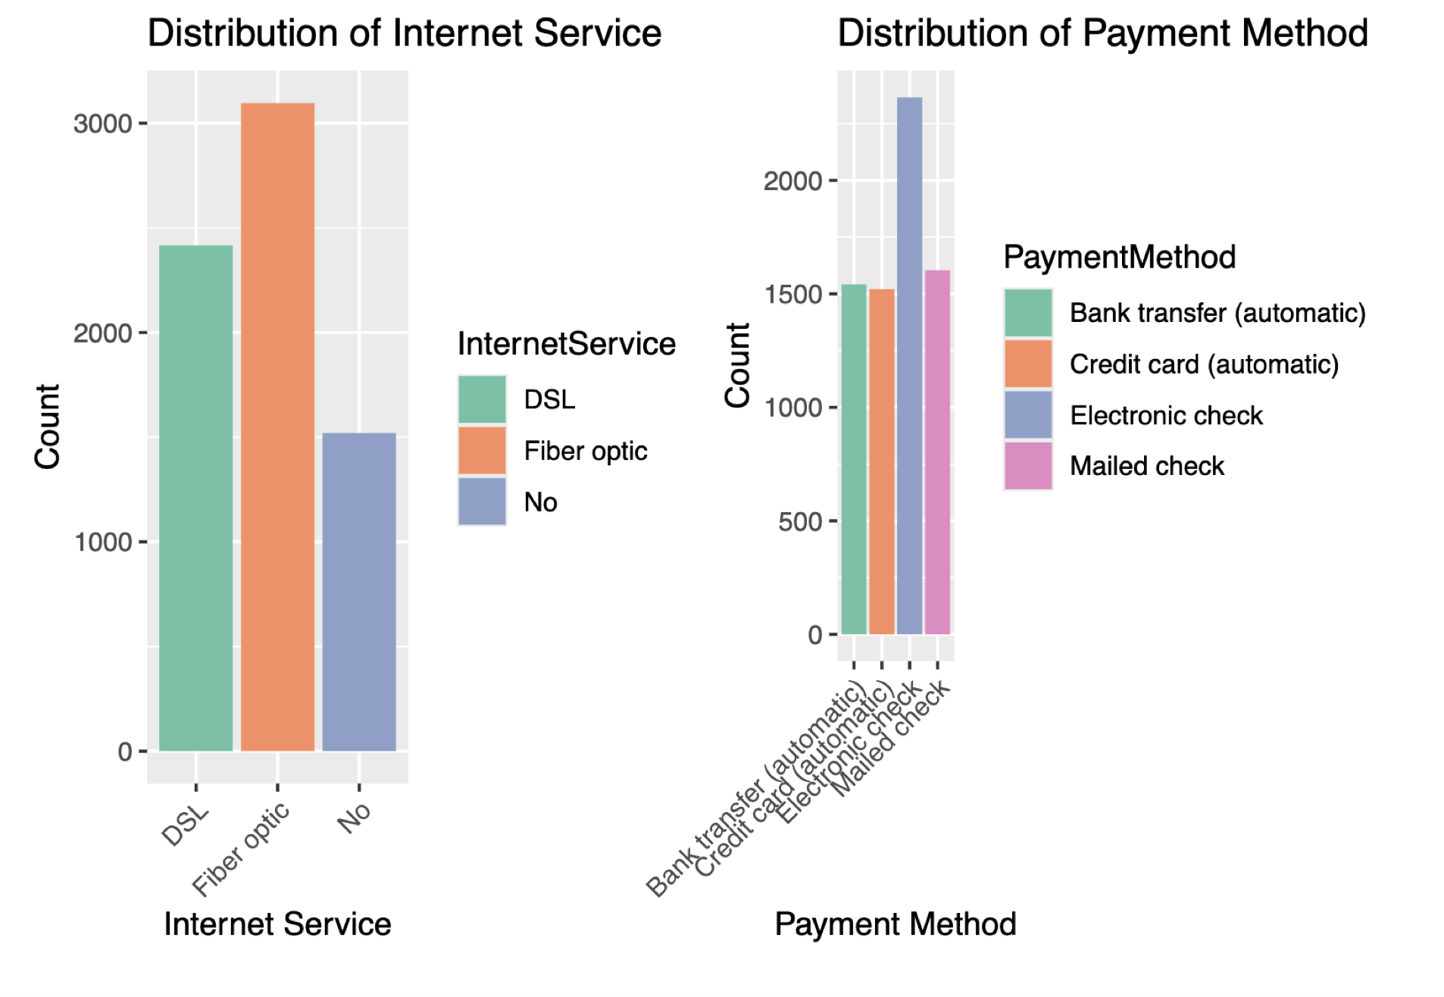

- Looking at the bar graph for “Internet Service,” we can see that Fiber optic is the top choice among internet users, followed by DSL and a small percentage of users not utilizing any internet service.
- Check it out - Electronic Check is by far the most popular payment method, with the other three options lagging by almost 25%. Looks like moving towards a more digital world!

# Plotting Bar graphs of SeniorCitizen, Partner, Dependents, PhoneService,MultipleLines and OnlineSecurity.
p14 <- ggplot(datrecode, aes(x = SeniorCitizen)) + geom_bar() +
geom_text(aes(y = ..count.. -400,
label = paste0(round(prop.table(..count..),4)*100, '%')),
stat = 'count')+ ggtitle("SeniorCitizen")
p15 <- ggplot(datrecode, aes(x = Partner)) + geom_bar() +
geom_text(aes(y = ..count.. -400,
label = paste0(round(prop.table(..count..),4)*100, '%')),
stat = 'count')+ ggtitle("Partner")
p16 <- ggplot(datrecode, aes(x = Dependents)) + geom_bar() +
geom_text(aes(y = ..count.. -400,
label = paste0(round(prop.table(..count..),4)*100, '%')),
stat = 'count')+ ggtitle("Dependents")
p17 <- ggplot(datrecode, aes(x = PhoneService)) + geom_bar() +
geom_text(aes(y = ..count.. -400,
label = paste0(round(prop.table(..count..),4)*100, '%')),
stat = 'count')+ ggtitle("PhoneService")
p18 <- ggplot(datrecode, aes(x = MultipleLines)) + geom_bar() +
geom_text(aes(y = ..count.. -400,
label = paste0(round(prop.table(..count..),4)*100, '%')),
stat = 'count')+ ggtitle("MultipleLines")
p19 <- ggplot(datrecode, aes(x = OnlineSecurity)) + geom_bar() +
geom_text(aes(y = ..count.. -400,
label = paste0(round(prop.table(..count..),4)*100, '%')),
stat = 'count')+ ggtitle("OnlineSecurity")
# Arrange plots in a grid
grid.arrange(p14,p15,p16,p17,p18,p19, nrow = 2, ncol = 3)

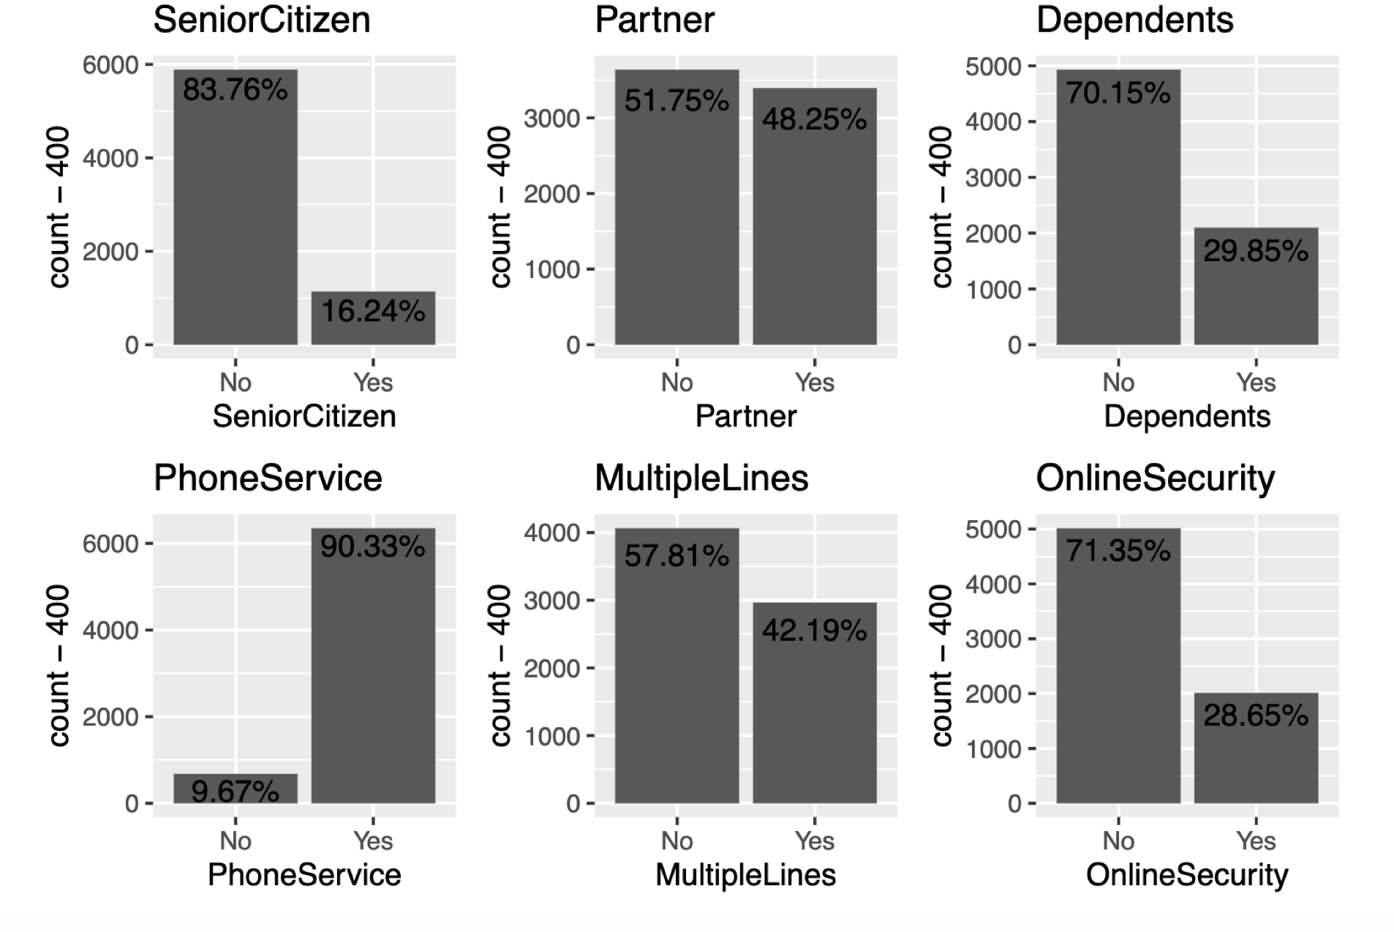

- Most people are not senior citizens.
- The number of users with partners and without partners is almost the same.
- About 70% of users have dependents.
- More than 90% of users have phone service, and most of them have a single line.
- Approximately 70% of users are vulnerable (not secured).
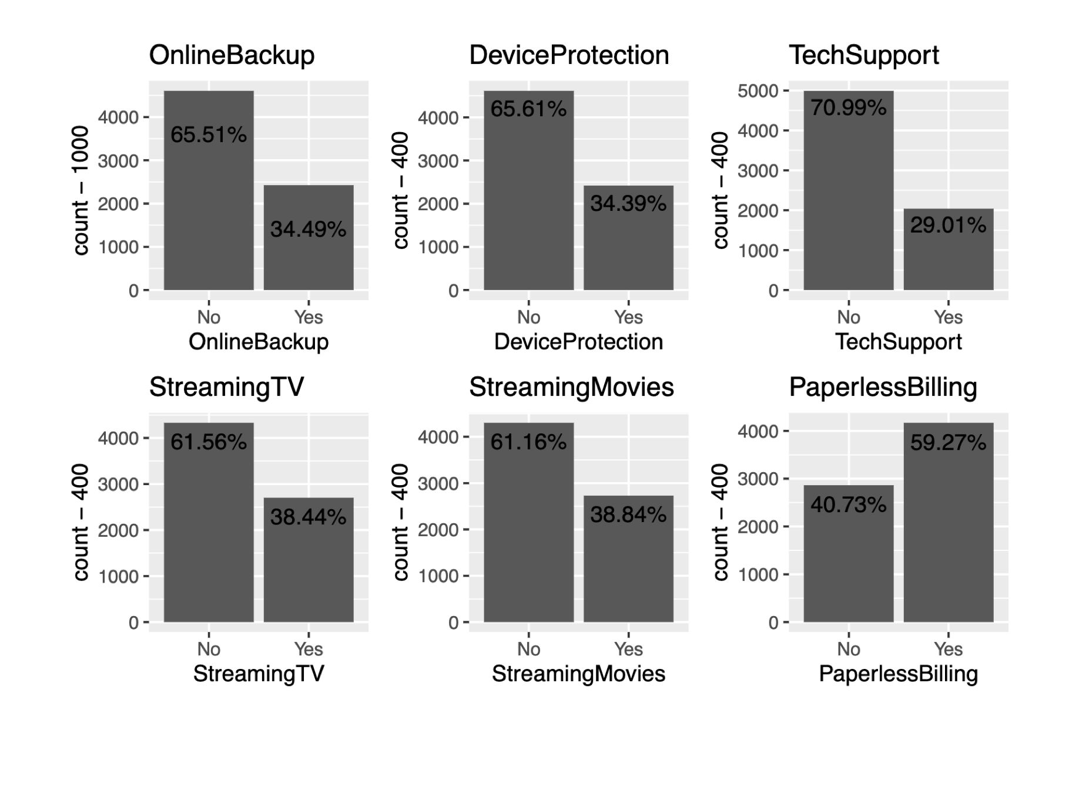
- Most customers (Above 60%) have OnlinBackup, DeviceProtection, TechSupport, StreamingTV and StreamingMovies. It means these services are very popular among the population and a must have in any company.

Answers to Research Questions

Does the payment method contribute to why customers churn?

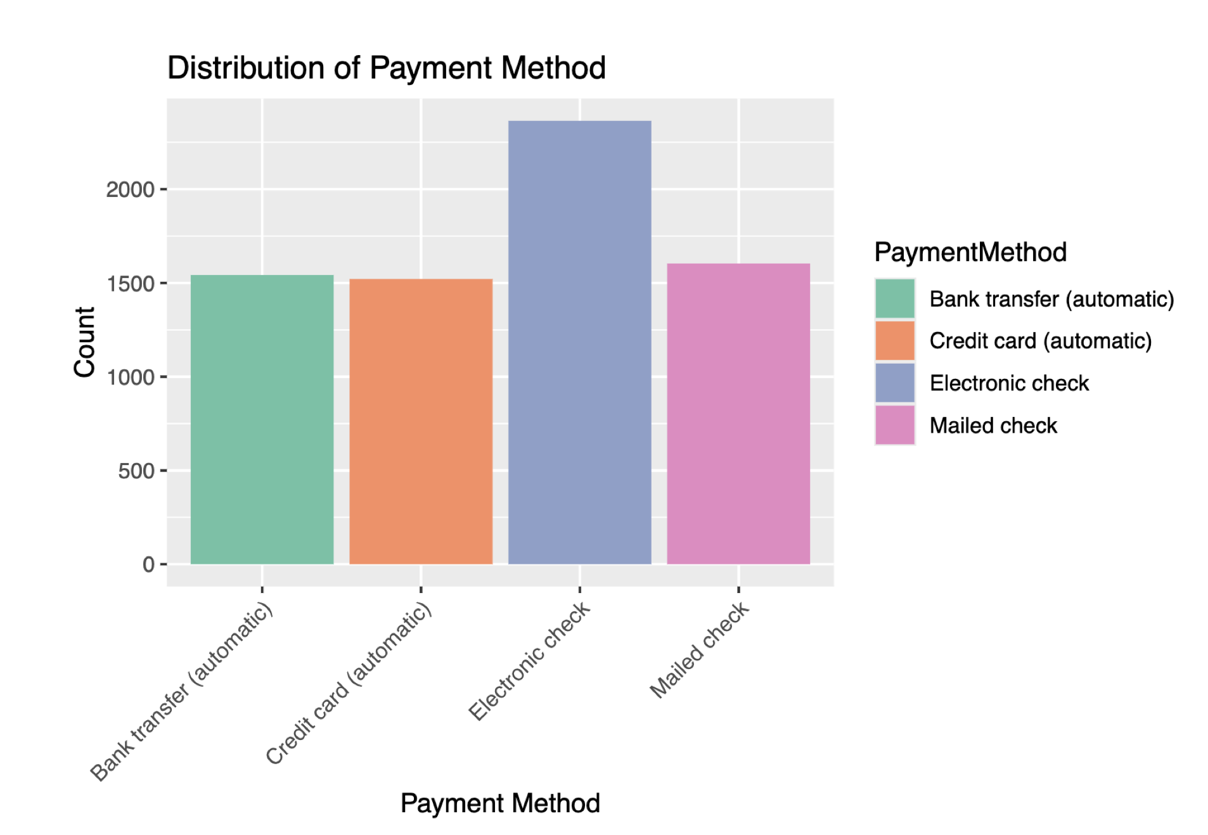

Looking at the payment methods, customer who were churning most were customer that used electronic checks followed by customer that used mail. Bank transfers and credit cards payment had the lowest number of customers churning and very fast in term off payment.

How does the length of a customer’s contract affect their likelihood to churn?

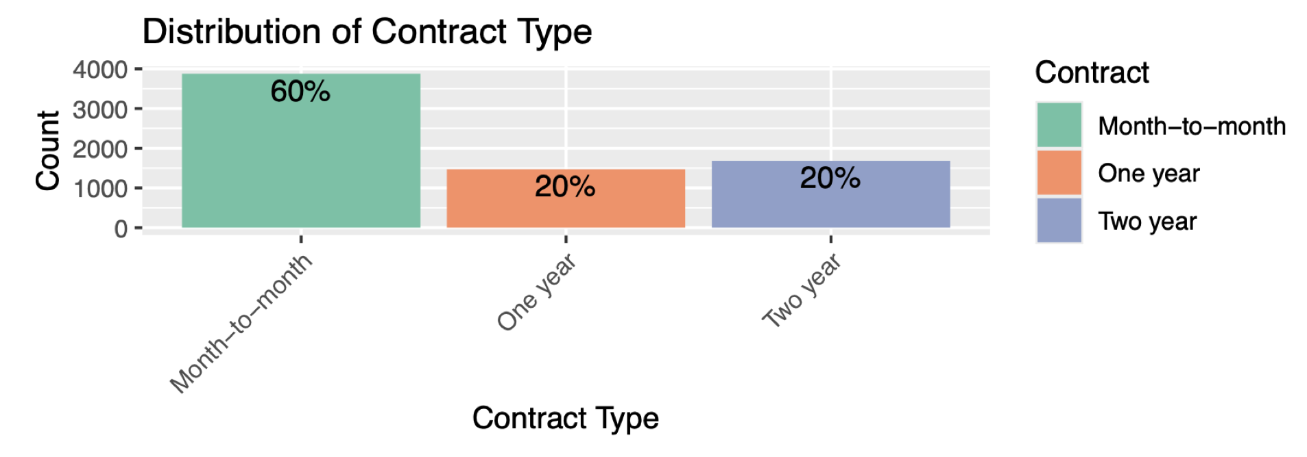

Most of the customers opted for month-to-month contract. The number of monthly customers that churned is even more than the number of people who signed up for the year contract. The month-month option gave customer the flexibility to try the service and then leave when they weren’t satisfied with the service the telco company was producing.

What is the Distribution of Tenure over the period, the maximum and minimum.

The distribution of tenure for customers is mainly between 5 months and 70 months. It has customer who were new and had used the service for just one month. Then had people who had used the service for as long 72 months, I believe these were the unconditional loyal customer.

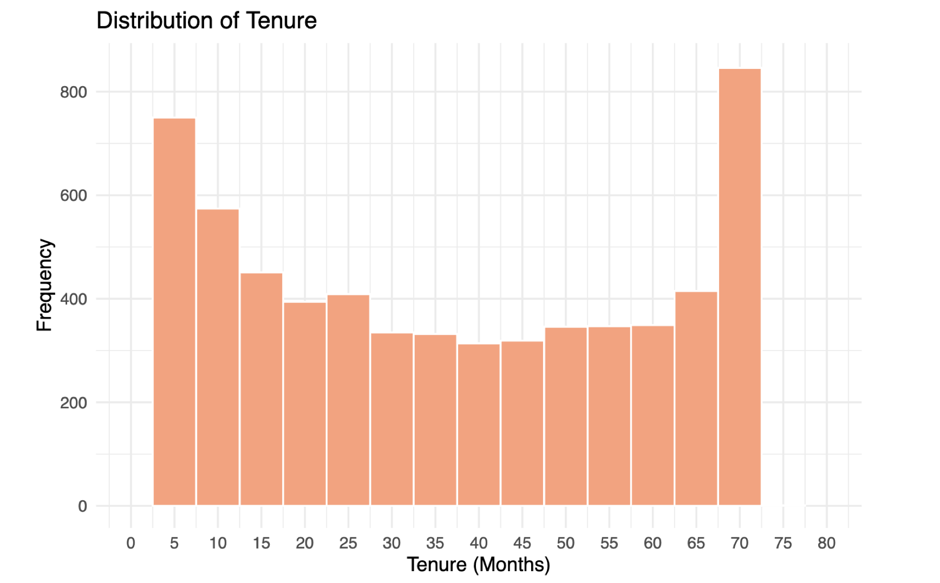

On an average monthly charge did customers pay to enjoy a particular Internet Service and how did it affect customer Churn.

Customers paid approximately more for fiberoptic compared to other internet service provider and if I ballpark then female customers pay more for it.
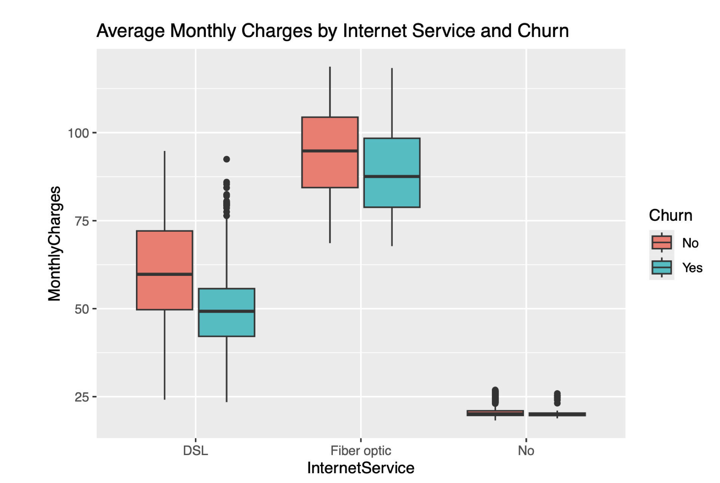

What are the average monthly charges of Senior Citizens and Non-Senior under a particular payment method and how does it affect customer Churn.

It looks like that overall Mailed checks again are most common type of payment method for paying small monthly bills by customers. It is interesting to note that Senior Citizens do not like to mail checks rather prefer to pay by electronic checks which is interesting to know because one would think that senior citizens would be more old school.

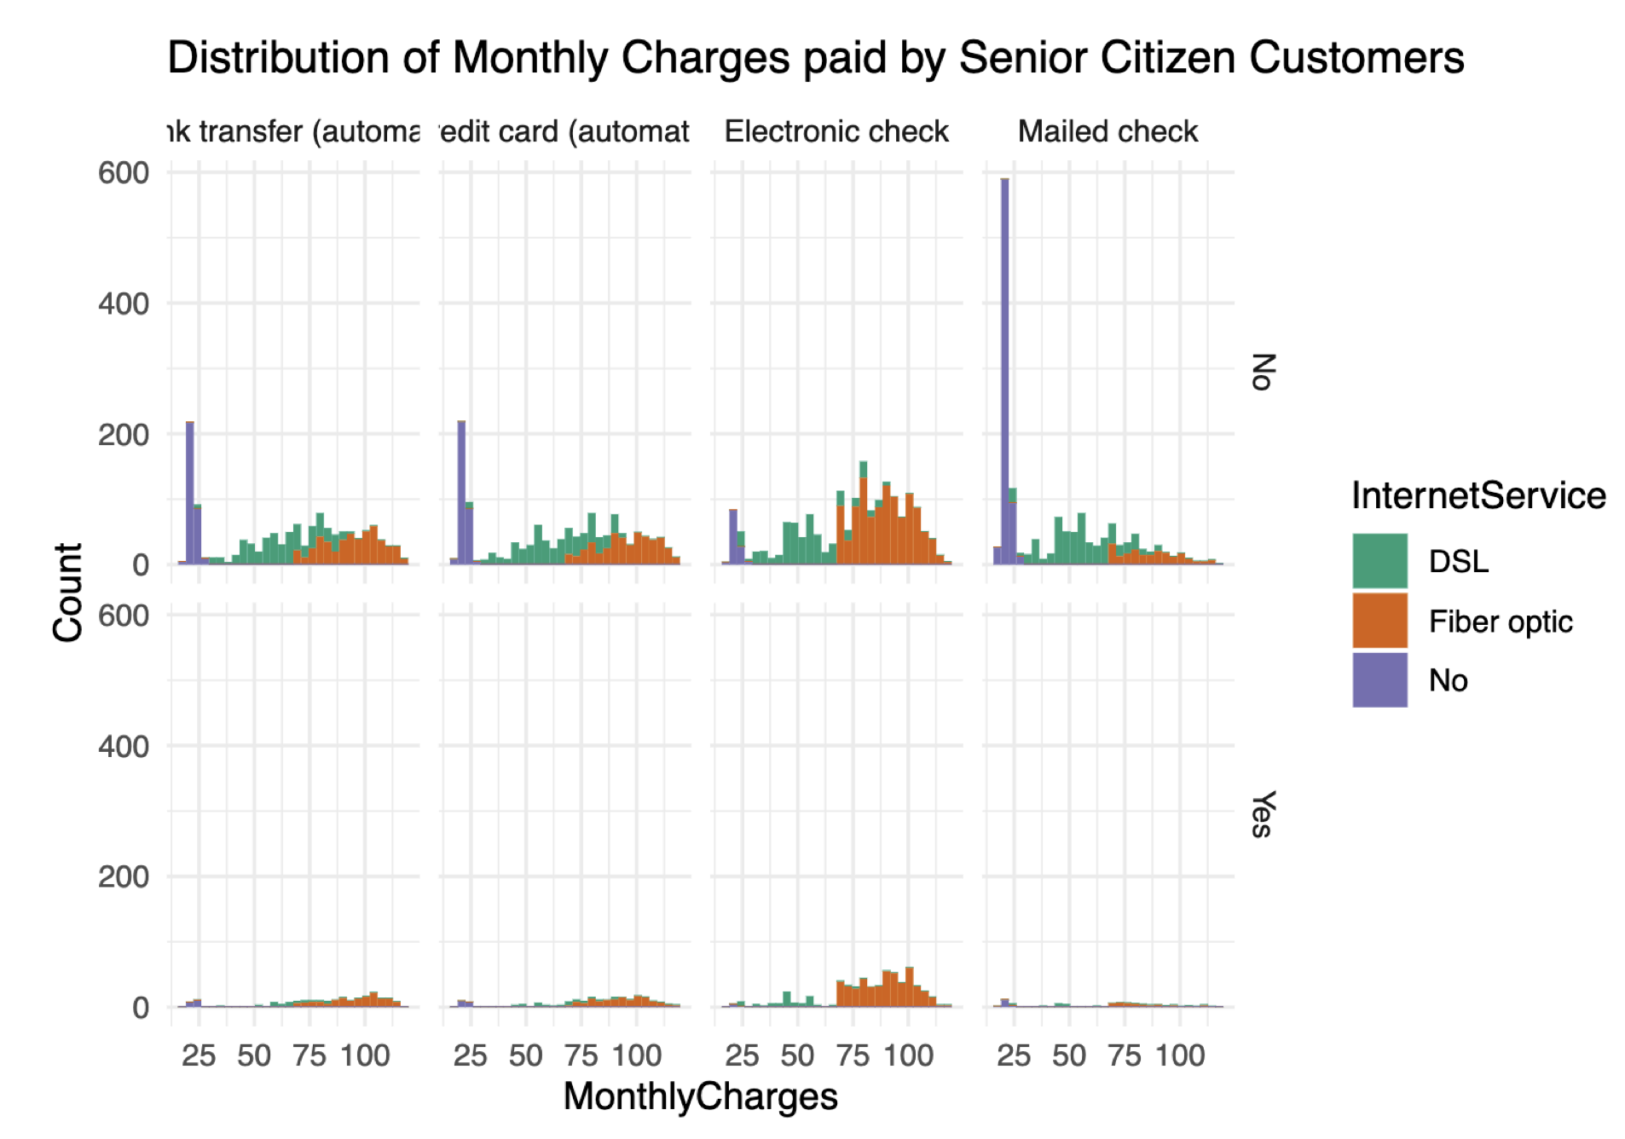

How Approach Addresses the Problem

Method

Data-Driven Insights: It can identify patterns and churn factors directly impacting customers and payment method by analyzing large and diverse datasets, including demographics, Internet Providers, and payment method.

Predictive Modeling: using predictive modeling techniques to identify which customers of a telecommunications company are likely to cancel their service (churn) in the near future, allowing the company to proactively take steps to retain them, while "predictive modeling" is the broader practice of using data analysis to forecast future outcomes, in this case, predicting customer churn based on historical data like usage patterns, billing details, and customer demographics.

Actionable Recommendations: The insights and predictions derived from our data analysis can inform actionable strategies.

Offer exclusive deals and promotions to high-risk churners based on their specific needs and usage patterns.

Send personalized messages highlighting the benefits of staying with the company.

Prioritize customer support interactions for high-risk churners.

Train customer service agents to address common churn triggers and proactively resolve issues.

Incentivize longer-term contracts with discounts or bonus features for customers with high churn risk.

Consider offering early termination fees for high-value customers who might be considering switching.

Potential Outcomes

Personalized promotions: Offering discounts or upgraded plans to high-risk customers based on their specific needs.

Customer service improvements: Addressing identified issues within customer service processes to enhance customer satisfaction.

Service plan adjustments: Modifying service packages to better align with customer usage patterns and prevent unnecessary churn.

Targeted marketing campaigns: Reaching out to at-risk customers with tailored messaging to highlight the value of their current service.

Limitations

Data Quality and Completeness: The effectiveness of our analysis is contingent upon the availability of high-quality, comprehensive data. Incomplete or inaccurate data could lead to misleading insights, affecting the reliability of our predictions and recommendations.

Generalizability: Our models may only apply to some populations, notably if the data lacks diversity. It is crucial to ensure that the data represents various demographics to avoid biases in predictive accuracy and healthcare recommendations.

Causality vs. Correlation: Our findings will predominantly reveal correlations, which must not be mistaken for causation. Interpreting these correlations should be cautious, especially in policy making and clinical decision-making contexts.

Model Complexity and Interpretability: While more sophisticated models might offer higher predictive accuracy, they can also be more challenging to interpret. This complexity can hinder the adoption of models in clinical practice where explainability is crucial.

Ethical and Privacy Concerns: Managing patient data involves strict adherence to ethical guidelines and privacy regulations. Ensuring the confidentiality and integrity of patient information is paramount and may restrict the extent of data utilization.

Modeling

To address the problem of customer churn, I utilized a comprehensive dataset including key data points like customer demographics, purchase history, website interactions etc. which was cleaned and preprocessed to ensure data quality. I employed a supervised machine learning approach, specifically a different model type e.g., Logistic Regression, Random Forest or Decision Tree model, to identify patterns within the data and predict customer churn. These models were trained using cross-validation techniques to optimize its performance and minimize overfitting. Key features considered in the model included key features, e.g., recent purchase frequency, average order value, website engagement metrics.

Following are the different models tried to analyze customer churn.

Correlation between numeric variables

The Monthly Charges and Total Charges are correlated. So, one of them will be removed from the model. I will remove Total Charges.

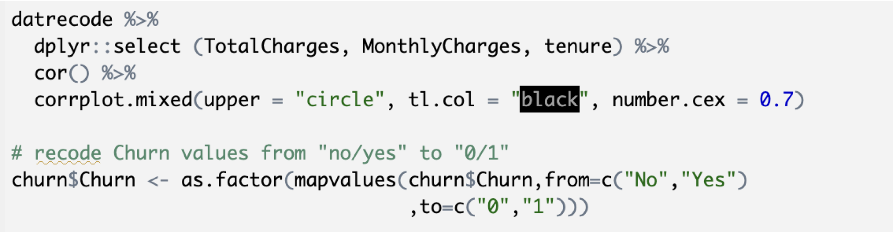
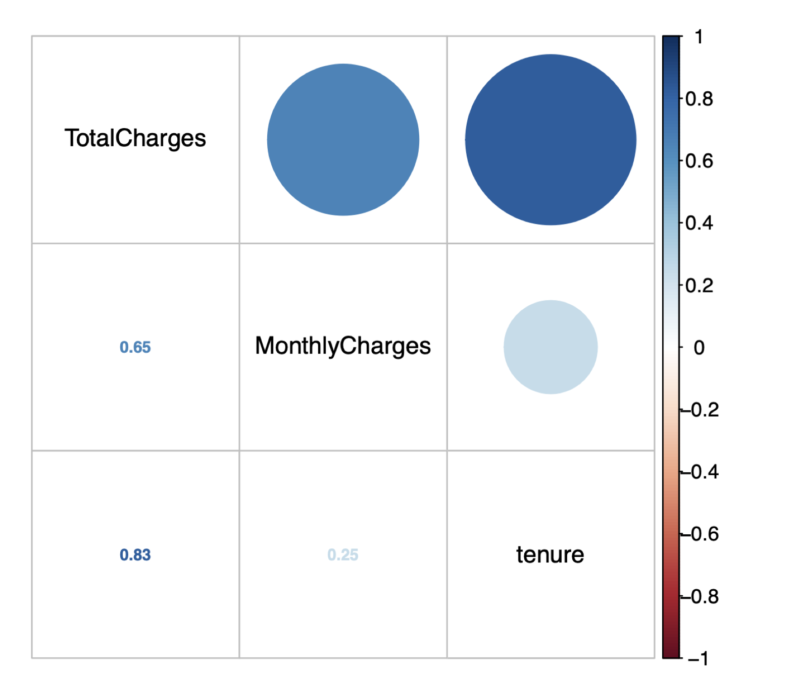

Logistic Regression

First, split the data into training and testing sets

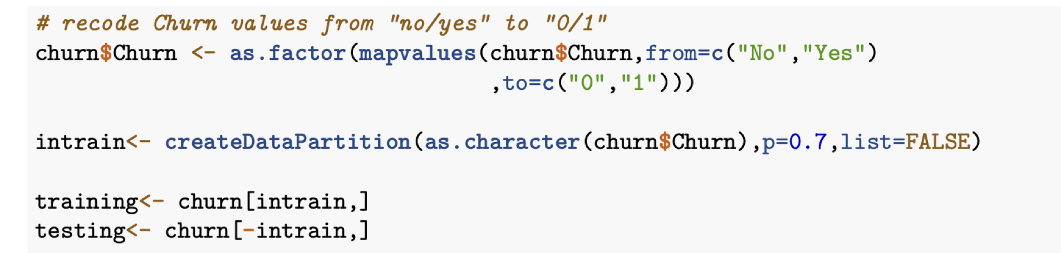

Confirm the splitting is correct

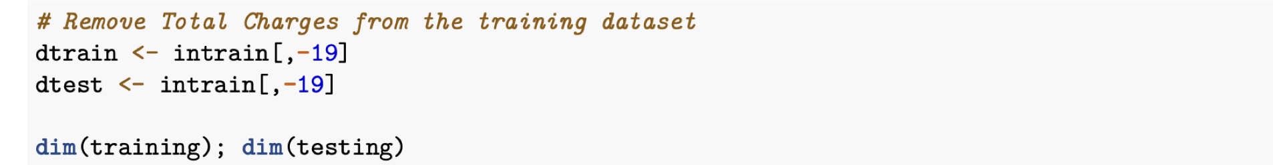

Fitting the Logistic Regression Model

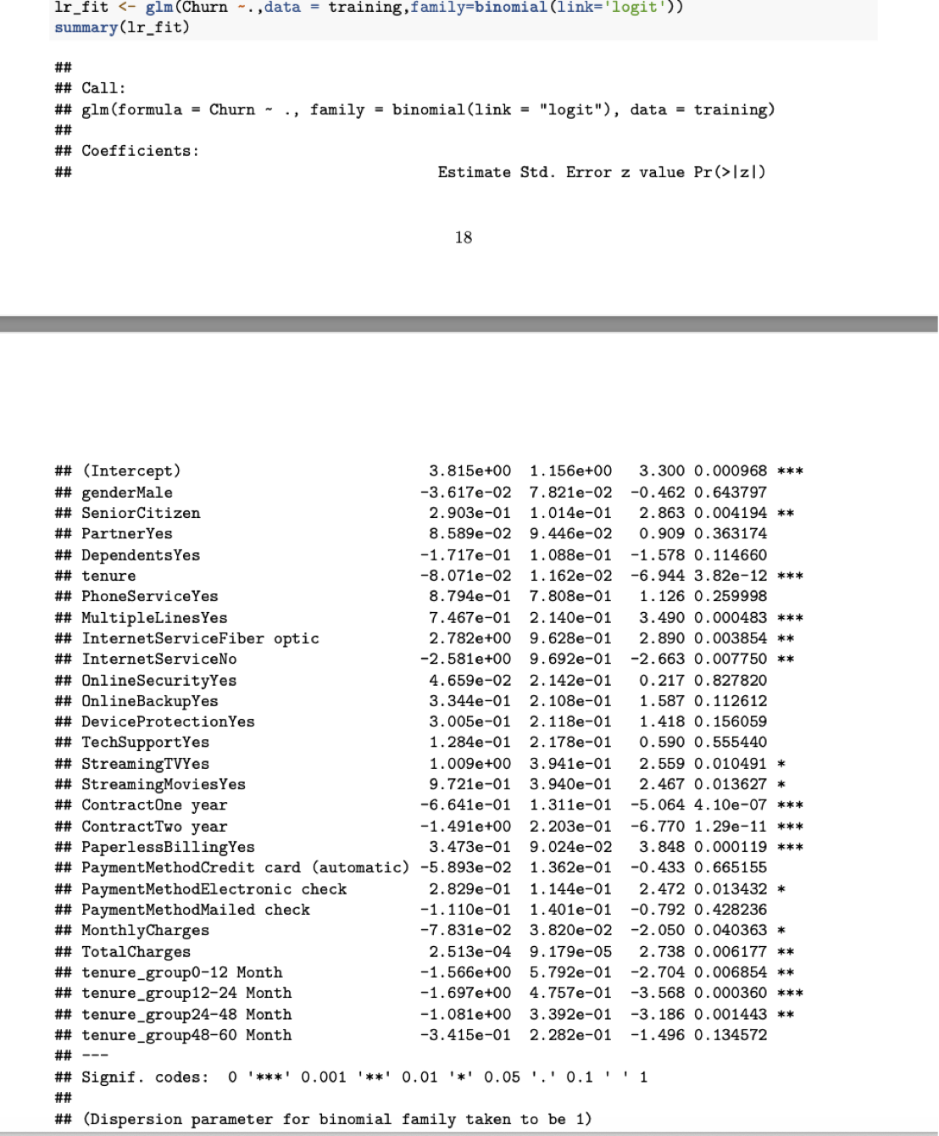

Feature Analysis
The top three most-relevant features include Contract, tenure_group and PaperlessBilling.

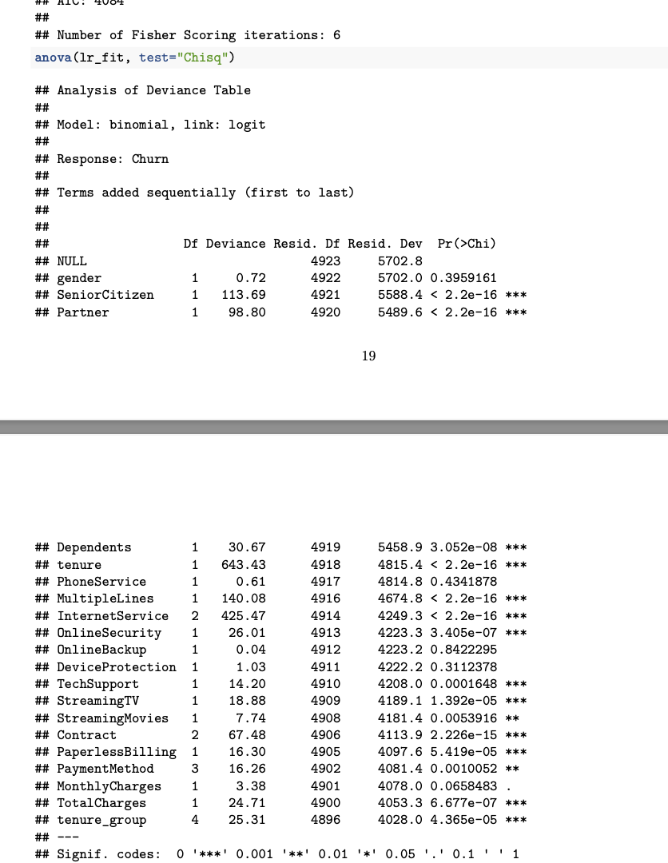
Analyzing the deviance table, that can see the drop in deviance when adding each variable one at a time. Adding Internet Service, Contract and tenure_group significantly reduces the residual deviance. The other variables such as PaymentMethod and Dependents seem to improve the model less even though they all have low p-values.

Assessing the predictive ability of the Logistic Regression model

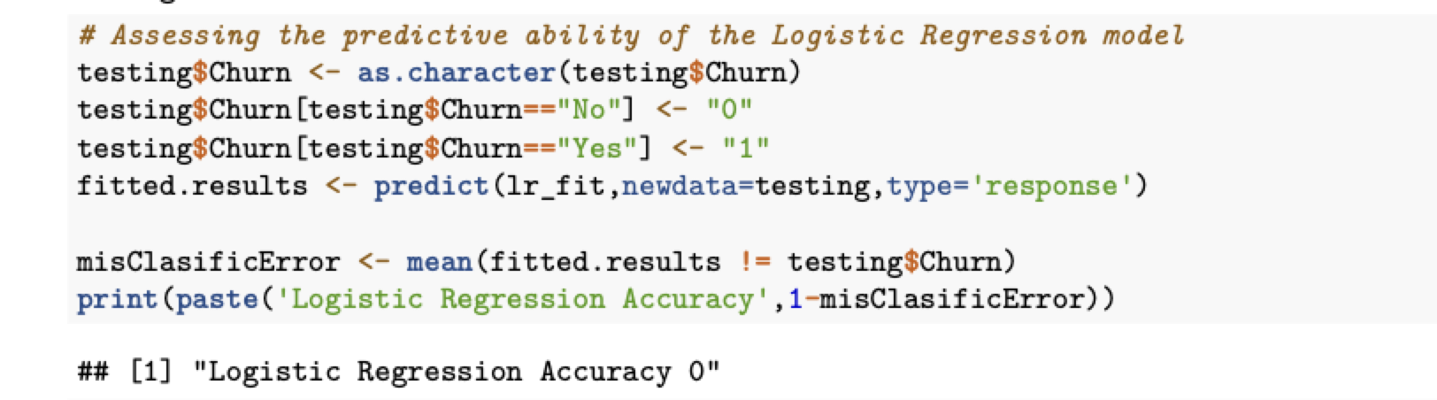

Logistic Regression Confusion Matrix

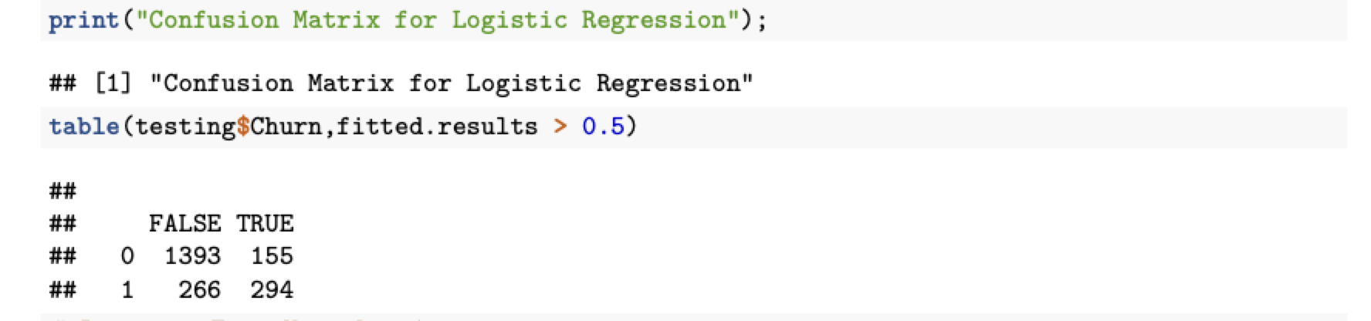

Random Forest

Random Forest Initial Model

The error rate is relatively low when predicting “No”, and the error rate is much higher when predicting “Yes”.

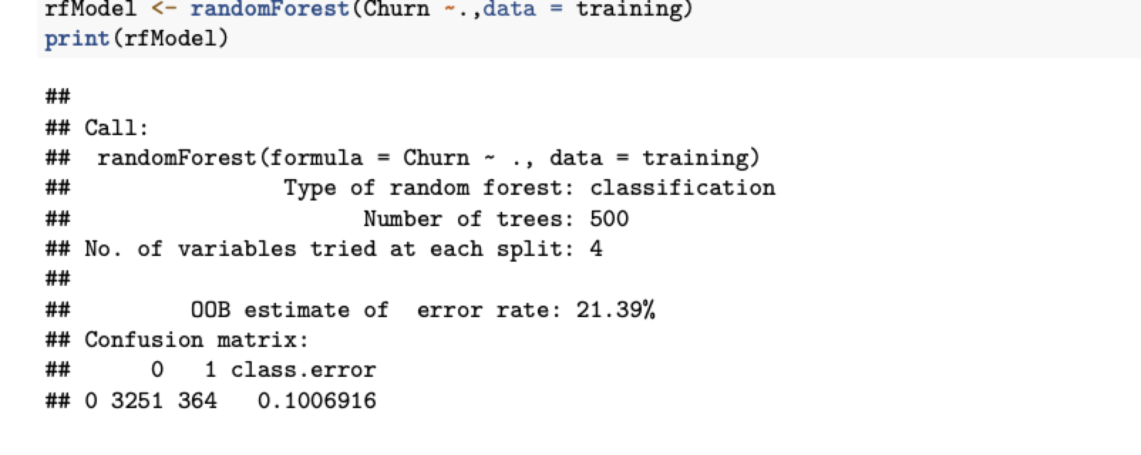

Random Forest Error Rate

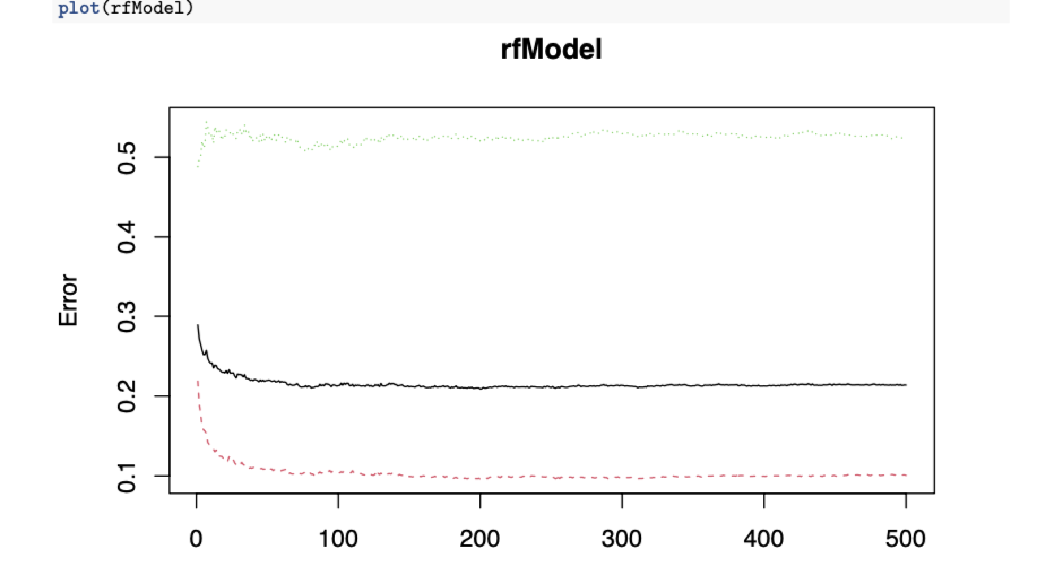

This plot to help determine the number of trees. As the number of trees increases, the OOB error rate decreases, and then becomes almost constant and not able to decrease the OOB error rate after about 100 to 200 trees.

Fit the Random Forest Model After Tuning

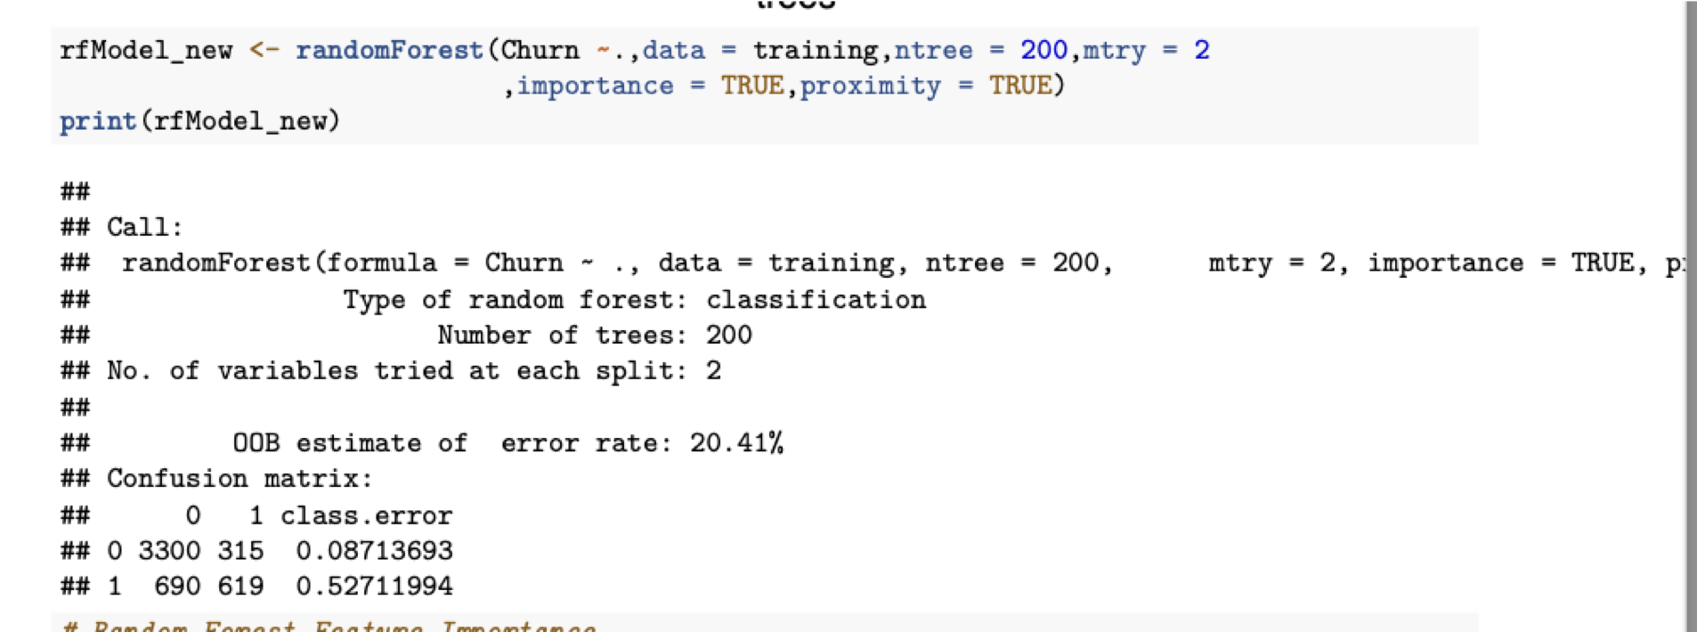

Random Forest Feature Importance

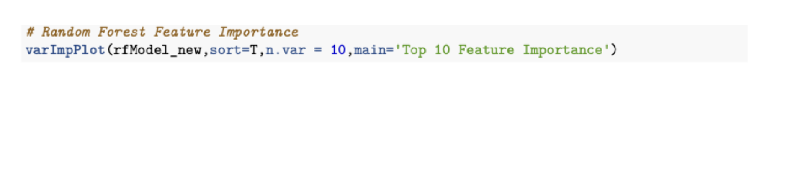

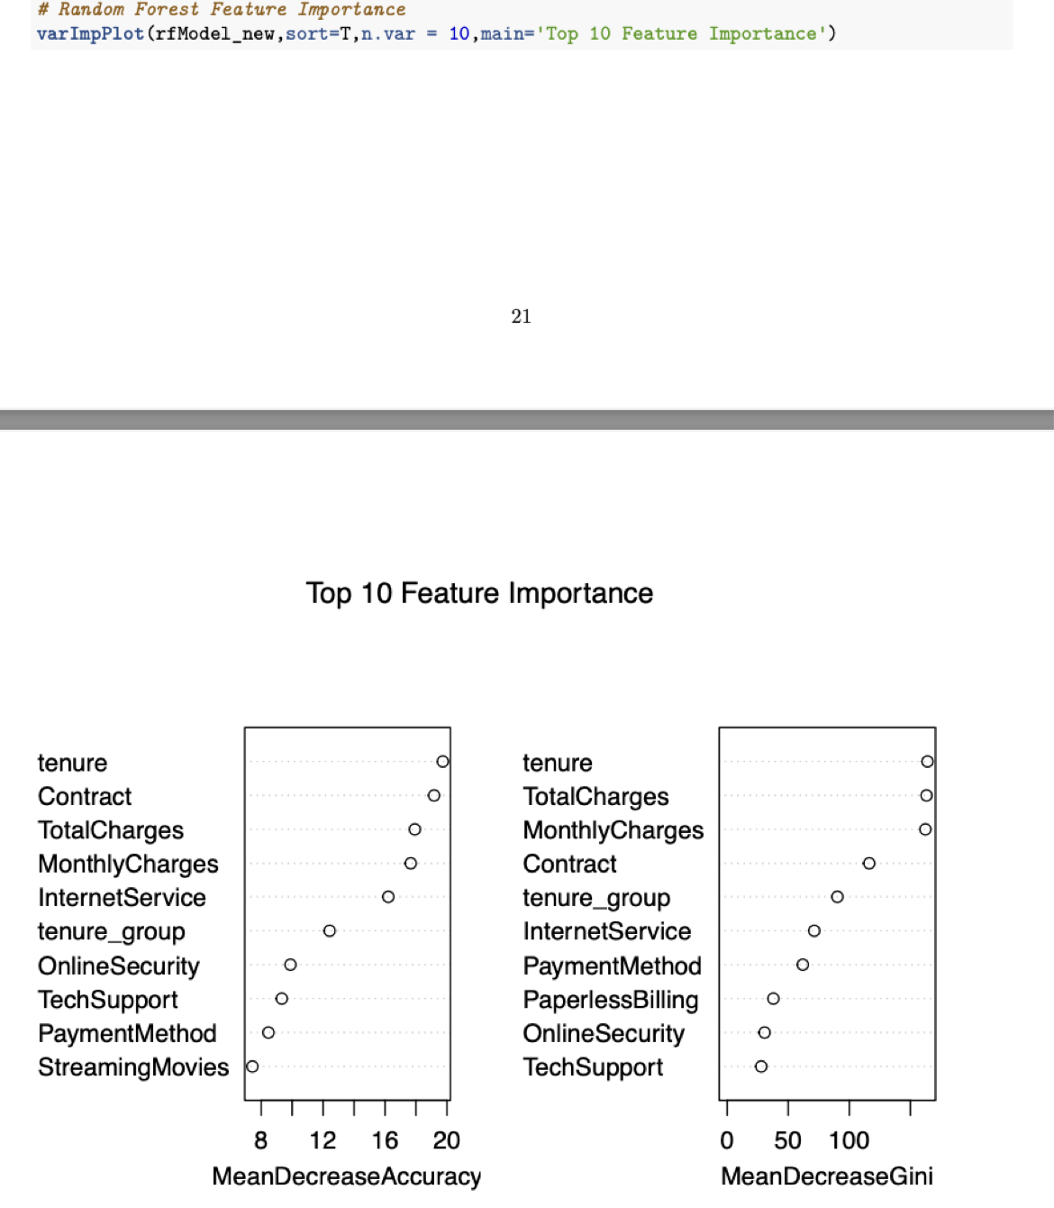

Summary
From the above example, I can see that Logistic Regression and Random Forest performed better than other models i.e. decision tree for customer churn analysis for this dataset.

Throughout the analysis, I have learned several important things:
1. Features such as tenure_group, Contract, PaperlessBilling, MonthlyCharges and InternetService appear to play a role in customer churn.
2. There does not seem to be a relationship between gender and churn.
3. Customers in a month-to-month contract, with PaperlessBilling and are within 12 months tenure, are more likely to churn; On the other hand, customers with one- or two-year contract, with longer than 12 months tenure, that are not using PaperlessBilling, are less likely to churn.

Conclusion

In conclusion, our analysis aimed to predict customer churn using various predictive models. The Logistic Regression model proved to be a robust baseline model, achieving the highest accuracy among the three models. Although the Random Forest models provided comparable accuracy, this requires further tuning to reduce overfitting and potentially improve their performance.
I identified some key predictors of customer churn, such as internet service type, contract duration, and availability of online security and backup. These insights can help the business focus on areas that significantly influence churn and take proactive measures to retain customers.
In conclusion, my study highlights the importance of predictive modeling in understanding customer behavior and churn patterns. By leveraging these models, businesses can make data-driven decisions to optimize customer retention strategies and ultimately enhance customer satisfaction and loyalty.

